**DAILY ONLINE ACTIVITIES SUMMARY**

|  |  |  |  |  |  |  |  |  |
| --- | --- | --- | --- | --- | --- | --- | --- | --- |
| **Date:** | **05-06-2020** | | | | | **Name:** | **Raksha S** | |
| **Sem & Sec** | **6th B** | | | | | **USN:** | **4AL17CS073** | |
| **Online Test Summary** | | | | | | | | |
| **Subject** | | **OR** | | | | | | |
| **Max. Marks** | | **30** | | **Score** | | | **30** | |
| **Certification Course Summary** | | | | | | | | |
| **Course** | **FullStack Webdevelopment** | | | | | | | |
| **Certificate Provider** | | | **Greatlearning** | | **Duration** | | | **45 days** |
| **Coding Challenges** | | | | | | | | |
| Problem Statement: 1. Python program for slicing list and print 1st and last element  2. Java program to check if given linked list has a loop or not. | | | | | | | | |
| **Status:** YES, Completed all Programs | | | | | | | | |
| **Uploaded the report in Github** | | | | | **YES** | | | |
| **If yes Repository name** | | | | | <https://github.com/raksha05/Daily-Status>/Raksha-4AL17CS073/Raksha | | | |
| **Uploaded the report in slack** | | | | | **YES** | | | |

Online Test Details:

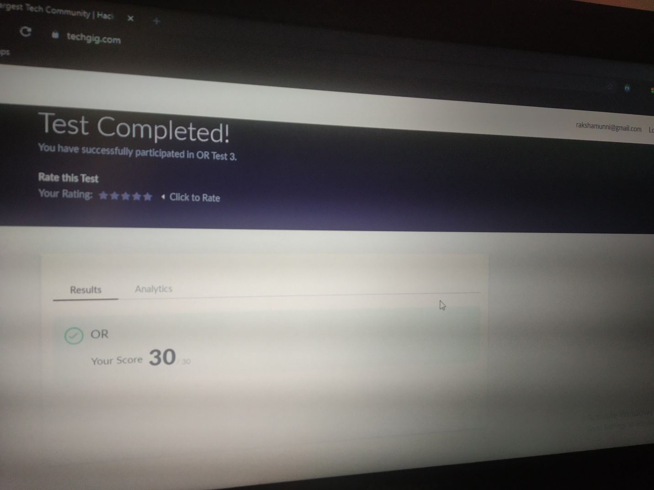

Scored 30 out of 30 in OR Test

Certification Course Details:

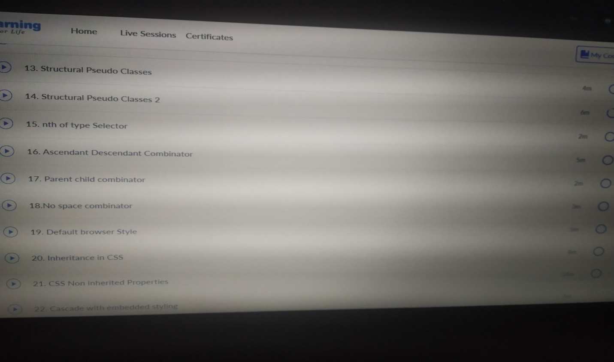

Today in online course based on FullStack Webdevelopment ,I learnt pseudo selectors different selectors where to use and in which order and which is the priorities(specificity) to be given among selectors.

Coding Challenges Details:

Program1:

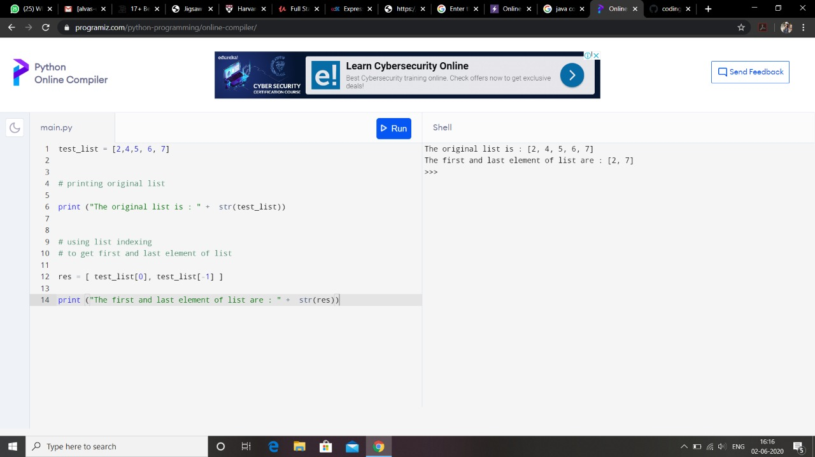

Program2:

